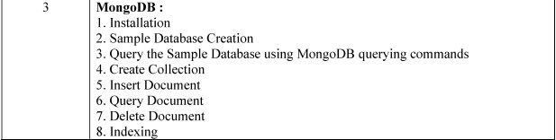

- Sample Database Creation
- Query the Sample Database using MongoDB querying commands
- Create Collection
- Insert Document
- Query Document
- Delete Document
- Indexing
MongoDB Practical

1. Installation
MongoDB can be installed from the official MongoDB website.

Steps (Windows):
- Download Community Server from mongodb.com
- Install using setup wizard → Select Complete Setup
- Add MongoDB to PATH (optional)
Start MongoDB server:
mongod

Open MongoDB shell:
mongosh

2. Sample Database Creation
Create a database named CollegeDB:
use CollegeDB

Show all available databases:
show databases

3. Query the Sample Database using MongoDB commands
To check current database:
db

To show collections in current DB:
show collections

4. Create Collection

Dynamic creation (auto on first insert):
db.Student.insertOne({roll: 1, name: "Amit", marks: 88})

Static creation:
db.createCollection("Student")

5. Insert Document
db.Student.insertMany([
{roll: 1, name: "Amit", marks: 88},
{roll: 2, name: "Sneha", marks: 92},
{roll: 3, name: "Rahul", marks: 75}
])

6. Query Document
Fetch all:
db.Student.find()

Formatted output:
db.Student.find().pretty()

Conditional search:
db.Student.find({marks: {$gt: 80}})

Projection:
db.Student.find({}, {name:1, marks:1})

7. Delete Document
Delete one record:
db.Student.deleteOne({roll: 3})

Delete multiple records:
db.Student.deleteMany({marks: {$lt: 60}})

Delete complete collection:
db.Student.drop()

8. Indexing
Indexes improve search efficiency.
Create index:
db.Student.createIndex({roll: 1})

Check existing indexes:
db.Student.getIndexes()

Drop index:
db.Student.dropIndex({roll: 1})

